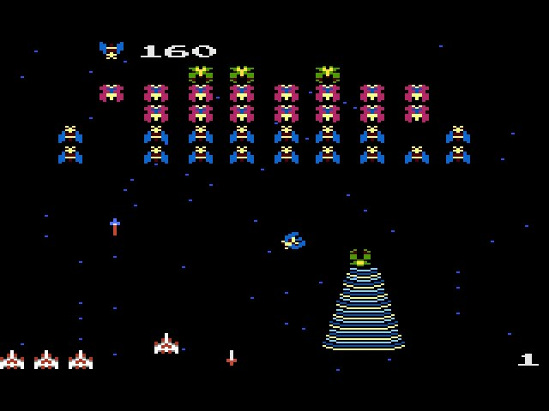Galaga 1981



**Abstract Factory**

BulletFactory

* SetInitialPosition
* SetDamage

**Builder**

EnemyBuilder

* Blue Enemy
* Red Enemy
* Green Enemy

**Mediator**

CollisionMediator

**PIMPL (pointer to implementation)**

Enemy

**Interface**

iEnemy